Outdoor explorer

see the world

a technical assignment for marklogic

**Author:** Ivana Frankic

Table of Contents

Introduction 3

Prerequisites/Installation guide 4

User guide 7

Future extensions/Limitations 8

Architecture 8

Technologies, frameworks and other dependencies 9

Full list of 3rd party libraries used 9

# Introduction

## Idea:

Outdoor Explorer is a community of travellers for travellers. It is a place for you to tell others where you’ve been and what you enjoyed. It is also a place for you to see where others have been and what they liked.

It is focused on motivating you to leave the office and explore the world by suggesting places you may like.

“Share your adventures with like-minded travellers and adventurers!”

**Motivation:**

The author is a travel enthusiast with a desire to create a community where travellers can share their experiences with different types of destinations, in one place, and explore further what others have visited, enjoyed or plan to visit with the goal to explore more.

**Disclaimer:**

No other projects or living creatures were harmed in the process of creating and testing this application.

This application is distributed as-is, with no warranties, and you are free to contribute and/or distribute further.

# Prerequisites/Installation guide

1. Unpack/download the project from github
2. It is required to have Java (tested with Java 8)
3. It is required to have MarkLogic Server (tested on MarkLogic 8) installed
4. This application uses REST API to communicate with MarkLogic, therefore it is a prerequisite to have a REST API instance
5. MarkLogic Configuration:
   1. REST API Instance used during the development was created following these instructions: <https://docs.marklogic.com/guide/rest-dev/service>  
        
      json file used for creating the REST API instance is in conf/create_restapi.json  
        
      (if you already have a MarkLogic REST API Instance you can skip this step)
   2. Creating rest-admin and rest-writer users as described in the guide is recommended
   3. If not already, enable collection lexicons with conf/collection-lexicon.json  
        
      (if you already have collection lexicons enabled on your database you can skip this step)
   4. This application uses a list of range path indexes  
        
      json file for adding these indexes to your database is provided in the conf/explorer_indexes.json  
        
      (you probably don’t have these indexes so don’t skip this step)
   5. List of curl commands used during the process of creating REST API instance and configuring indexes is supplied in the conf/curl_commands.txt
   6. Now go to your MarkLogic Server web portal, for example <http://localhost:8001/>
      1. Find the database you used in the above steps and additionally enable three character searches

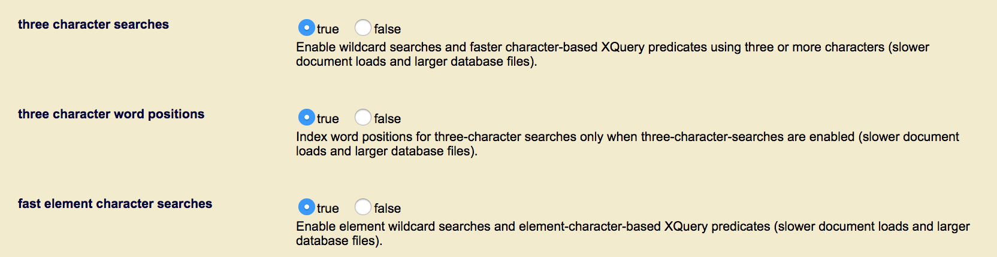

Now that your MarkLogic is configured for use from this application, let’s move on.

1. Once you are done with prerequisites, you need to configure the application for the first run
2. Enter the box/conf directory one more time
3. Edit file dbconn.properties in your favorite text editor; enter parameters for connecting to your MarkLogic REST API
4. This application runs on port 7000. You can modify this by editing a line in file box/conf/application.conf.   
   http.port=7000
5. Prepare this application for the first run:  
     
   Open your terminal and enter the box directory  
   Execute the following command:  
   (The command will find the required libraries for the application and preconfigure it for the first run. Once successfully executed, you do not need to repeat the step.)  
     
   $ ../play-1.4.4/play deps
6. Run the application  
   Open your terminal and enter the explorer directory (parent directory of the box)  
   Execute the following command:  
     
   $ ./play-1.4.4/play run box
7. What happens next? Open your browser and go to localhost:7000 to see the home page (if you changed the port for box, use the one you configured)
8. Your database will be populated with the initial set of objects on application start. Those objects and any other you may create during usage will be removed from your database on application stop.
9. How to stop the application? Just Ctrl-C in the terminal and it will stop.
10. If you are interested, Javadoc is available in box/doc/

# User guide

1. Explore
2. Sign-in or register
3. Like some destinations. Save some to your wish-list.
4. Add your own if it is not listed.
5. See what others liked or saved.
6. Plan your next vacation :)



# Future extensions/Limitations

1. Pagination. Currently (and badly) all database content is loaded on the home page. And all searches return all matches.
2. Geolocation – location on items. Find destinations near user’s location
3. Delete user/destination
4. Share on social networks
5. SSO or login integration with social networks
6. Localization
7. Written reviews on destinations and rating (stars, 1-5)
8. And much more..

# Architecture

Architecture is 3-tiered:

* Tier 1 – User interface
* Tier 2 – Web server
* Tier 3 – Database

Generic flow for data read/update would look like this:

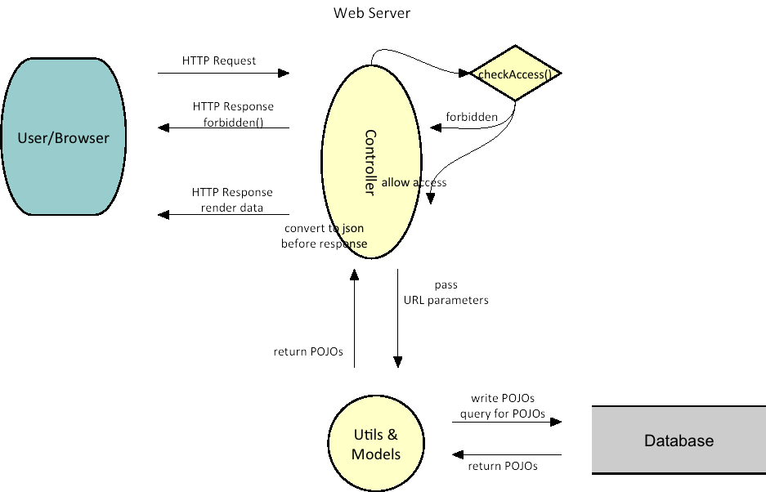

# Technologies, frameworks and other dependencies

This product uses:

1. HTML, JavaScript, Knockout
2. Java 8 and Play Framework 1.4.4
3. MarkLogic Java Client API 3.0.5

This product depends on MarkLogic Server 8

**Full list of 3rd party libraries**

1. JavaScript

public/javascripts/lib:

* + Chart.bundle.min.js
  + jquery-1.6.4.min.js
  + jquery.cookies.2.2.0.min.js
  + jquery.tmpl.min.js
  + json2.js
  + knockout-1.2.1.js
  + knockout.mapping-2.0.1.js
  + underscore-min.js

1. Java

lib/

* + commons-compiler-2.6.1.jar
  + geronimo-jms_1.1_spec-1.0.jar
  + httpclient-4.1.1.jar
  + httpcore-4.1.jar
  + jackson-annotations-2.4.1.jar
  + jackson-core-2.4.1.jar
  + jackson-databind-2.4.1.jar
  + janino-2.6.1.jar
  + java-client-api-3.0.5.jar
  + jaxb-api-2.1.jar
  + jersey-apache-client4-1.17.jar
  + jersey-client-1.17.jar
  + jersey-core-1.17.jar
  + jersey-multipart-1.17.jar
  + jsr311-api-1.1.1.jar
  + logback-classic-1.1.2.jar
  + logback-core-1.1.2.jar
  + mimepull-1.9.4.jar
  + org.osgi.core-4.2.0.jar
  + osgi_R4_core-1.0.jar
  + servlet-api-2.5.jar
  + stax-api-1.0-2.jar

1. Web Server:

play-1.4.4/framework/play-1.4.4.jar

play-1.4.4/framework/lib/ comes with Play Framework